let’s Talk Sexual Health: An Anonymous Student Survey

akh34704@uga.edu
Overall Survey Statistics

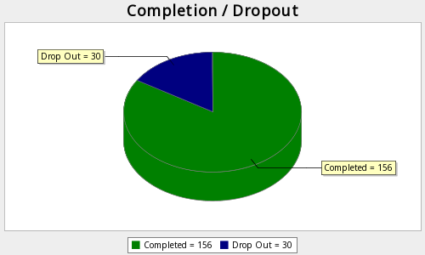

Viewed  435 | Started  186 | Completed  156 | Completion Rate  83.87% | Drop Outs (After Starting)  30 | Average Time to Complete Survey  2 minutes

Q1. You are invited to take part in a quality improvement project on sexual health awareness and HIV prevention (including PrEP) among college students ages 18–25.This project aims to understand how students access health information, what influences their sexual health decisions, and how to improve campus sexual health practices.If you participate, you will complete a brief (about 5 minutes), anonymous online survey about your demographics, knowledge of PrEP (Pre-Exposure Prophylaxis), and sexual health practices.By clicking “I Agree” you confirm that you are 18–25 years old, have read this information, and voluntarily agree to participate.

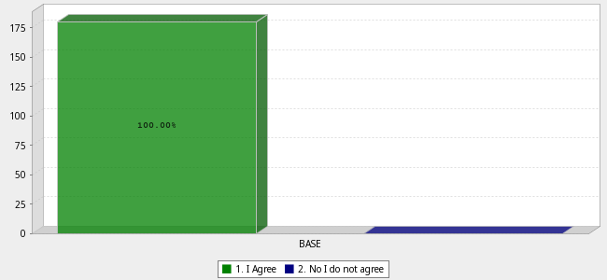
 |  | Answer |  |  |  | Count | Percent
1. |  | I Agree |  |  |  | 180 | 100.00%
2. |  | No I do not agree |  |  |  | 0 | 0.00%
 |  | Total |  |  |  | 180 | 100%
 | Mean : 1.000 |  | Confidence Interval @ 95% : [1.000 - 1.000] | Standard Deviation : 0.000 | Standard Error : 0.000
Q2. Where did you primarily grow up?

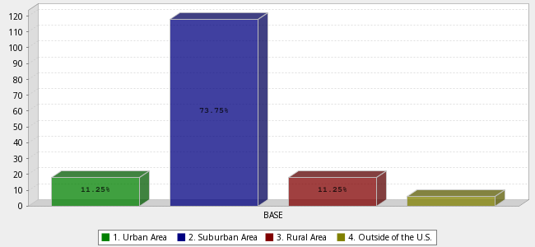
 |  | Answer |  |  |  | Count | Percent
1. |  | Urban Area |  |  |  | 18 | 11.25%
2. |  | Suburban Area |  |  |  | 118 | 73.75%
3. |  | Rural Area |  |  |  | 18 | 11.25%
4. |  | Outside of the U.S. |  |  |  | 6 | 3.75%
 |  | Total |  |  |  | 160 | 100%
 | Mean : 2.075 |  | Confidence Interval @ 95% : [1.981 - 2.169] | Standard Deviation : 0.610 | Standard Error : 0.048
Q2-C18. What type of community do you currently live in?

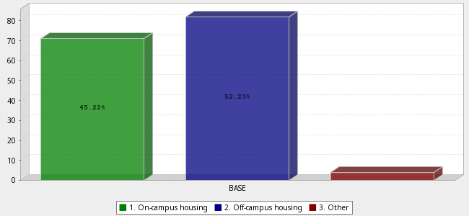
 |  | Answer |  |  |  | Count | Percent
1. |  | On-campus housing |  |  |  | 71 | 45.22%
2. |  | Off-campus housing |  |  |  | 82 | 52.23%
3. |  | Other |  |  |  | 4 | 2.55%
 |  | Total |  |  |  | 157 | 100%
 | Mean : 1.573 |  | Confidence Interval @ 95% : [1.488 - 1.659] | Standard Deviation : 0.545 | Standard Error : 0.044
Q2-C18-C19. How comfortable do you feel discussing sexual health with a provider?

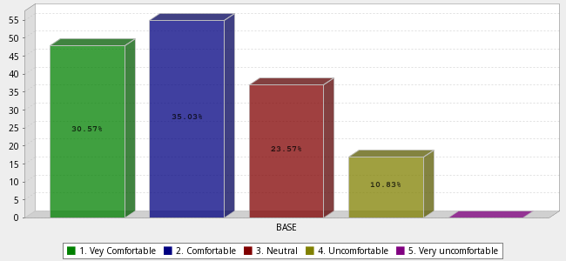
 |  | Answer |  |  |  | Count | Percent
1. |  | Vey Comfortable |  |  |  | 48 | 30.57%
2. |  | Comfortable |  |  |  | 55 | 35.03%
3. |  | Neutral |  |  |  | 37 | 23.57%
4. |  | Uncomfortable |  |  |  | 17 | 10.83%
5. |  | Very uncomfortable |  |  |  | 0 | 0.00%
 |  | Total |  |  |  | 157 | 100%
 | Mean : 2.146 |  | Confidence Interval @ 95% : [1.993 - 2.300] | Standard Deviation : 0.979 | Standard Error : 0.078
Q3. Have you ever avoided seeking sexual health services due to discomfort or stigma?

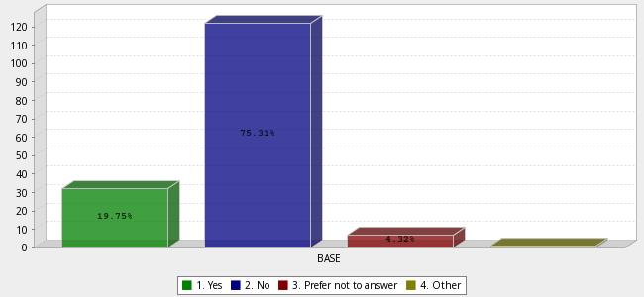
 |  | Answer |  |  |  | Count | Percent
1. |  | Yes |  |  |  | 32 | 19.75%
2. |  | No |  |  |  | 122 | 75.31%
3. |  | Prefer not to answer |  |  |  | 7 | 4.32%
4. |  | Other |  |  |  | 1 | 0.62%
 |  | Total |  |  |  | 162 | 100%
 | Mean : 1.858 |  | Confidence Interval @ 95% : [1.782 - 1.935] | Standard Deviation : 0.497 | Standard Error : 0.039
Q5. Have you had sexual intercourse in the last 6 months?(Sexual intercourse is consensual sexual activity involving genital contact or penetration between people, regardless of their gender identities.)

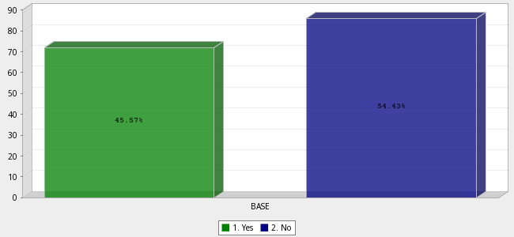
 |  | Answer |  |  |  | Count | Percent
1. |  | Yes |  |  |  | 72 | 45.57%
2. |  | No |  |  |  | 86 | 54.43%
 |  | Total |  |  |  | 158 | 100%
 | Mean : 1.544 |  | Confidence Interval @ 95% : [1.466 - 1.622] | Standard Deviation : 0.500 | Standard Error : 0.040
Q6. Do you consistently use protection (e.g. condoms) during sex?

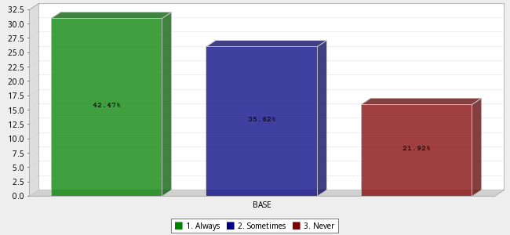
 |  | Answer |  |  |  | Count | Percent
1. |  | Always |  |  |  | 31 | 42.47%
2. |  | Sometimes |  |  |  | 26 | 35.62%
3. |  | Never |  |  |  | 16 | 21.92%
 |  | Total |  |  |  | 73 | 100%
 | Mean : 1.795 |  | Confidence Interval @ 95% : [1.615 - 1.974] | Standard Deviation : 0.781 | Standard Error : 0.091
Q7. What kind of unprotected sex did you participate in? (Select all that apply)

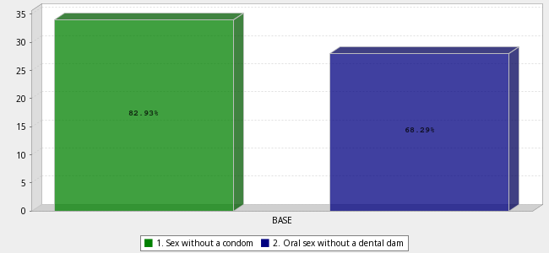
 |  | Answer |  |  |  | Count | Percent
1. |  | Sex without a condom |  |  |  | 34 | 82.93%
2. |  | Oral sex without a dental dam |  |  |  | 28 | 68.29%
 |  | Total |  |  |  | 62 | n = 41.0
 | Mean : 1.452 |  | Confidence Interval @ 95% : [1.327 - 1.577] | Standard Deviation : 0.502 | Standard Error : 0.064
Q8. In the past 6 months, how many sexual partners have you had?

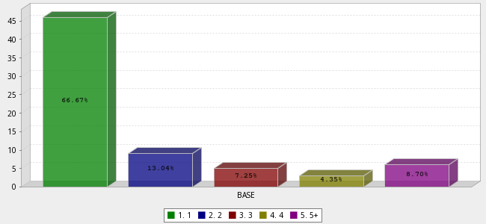
 |  | Answer |  |  |  | Count | Percent
1. |  | 1 |  |  |  | 46 | 66.67%
2. |  | 2 |  |  |  | 9 | 13.04%
3. |  | 3 |  |  |  | 5 | 7.25%
4. |  | 4 |  |  |  | 3 | 4.35%
5. |  | 5+ |  |  |  | 6 | 8.70%
 |  | Total |  |  |  | 69 | 100%
 | Mean : 1.754 |  | Confidence Interval @ 95% : [1.450 - 2.058] | Standard Deviation : 1.288 | Standard Error : 0.155
Q19. How confident are you in your knowledge about preventing sexually transmitted infections (STIs)?

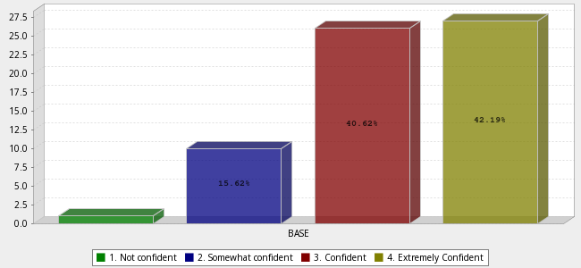
 |  | Answer |  |  |  | Count | Percent
1. |  | Not confident |  |  |  | 1 | 1.56%
2. |  | Somewhat confident |  |  |  | 10 | 15.62%
3. |  | Confident |  |  |  | 26 | 40.62%
4. |  | Extremely Confident |  |  |  | 27 | 42.19%
 |  | Total |  |  |  | 64 | 100%
 | Mean : 3.234 |  | Confidence Interval @ 95% : [3.045 - 3.423] | Standard Deviation : 0.771 | Standard Error : 0.096
Q18. Which factors most influence your sexual health decisions?(Choose up to 3)

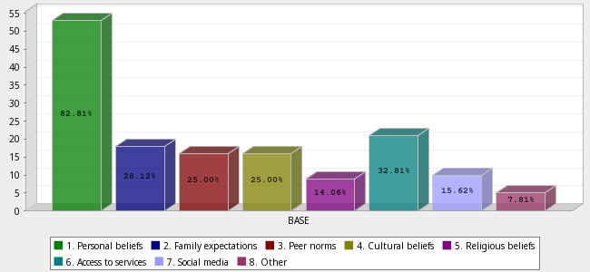
 |  | Answer |  |  |  | Count | Percent
1. |  | Personal beliefs |  |  |  | 53 | 82.81%
2. |  | Family expectations |  |  |  | 18 | 28.12%
3. |  | Peer norms |  |  |  | 16 | 25.00%
4. |  | Cultural beliefs |  |  |  | 16 | 25.00%
5. |  | Religious beliefs |  |  |  | 9 | 14.06%
6. |  | Access to services |  |  |  | 21 | 32.81%
7. |  | Social media |  |  |  | 10 | 15.62%
8. |  | Other |  |  |  | 5 | 7.81%
 |  | Total |  |  |  | 148 | n = 64.0
 | Mean : 3.257 |  | Confidence Interval @ 95% : [2.894 - 3.620] | Standard Deviation : 2.253 | Standard Error : 0.185
Q9. Are you familiar with PrEP (pre-exposure prophylaxis)?

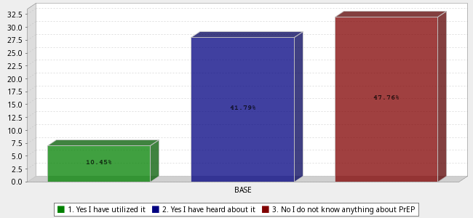
 |  | Answer |  |  |  | Count | Percent
1. |  | Yes I have utilized it |  |  |  | 7 | 10.45%
2. |  | Yes I have heard about it |  |  |  | 28 | 41.79%
3. |  | No I do not know anything about PrEP |  |  |  | 32 | 47.76%
 |  | Total |  |  |  | 67 | 100%
 | Mean : 2.373 |  | Confidence Interval @ 95% : [2.213 - 2.534] | Standard Deviation : 0.671 | Standard Error : 0.082
Q10. Where have you utilized PrEP?

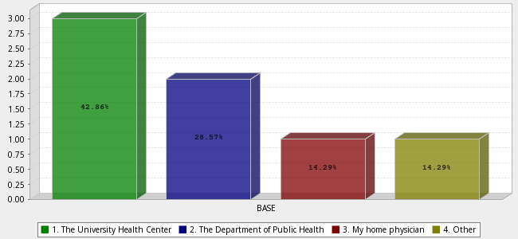
 |  | Answer |  |  |  | Count | Percent
1. |  | The University Health Center |  |  |  | 3 | 42.86%
2. |  | The Department of Public Health |  |  |  | 2 | 28.57%
3. |  | My home physician |  |  |  | 1 | 14.29%
4. |  | Other |  |  |  | 1 | 14.29%
 |  | Total |  |  |  | 7 | 100%
 | Mean : 2.000 |  | Confidence Interval @ 95% : [1.145 - 2.855] | Standard Deviation : 1.155 | Standard Error : 0.436
Q11. Where have you heard about PrEP?

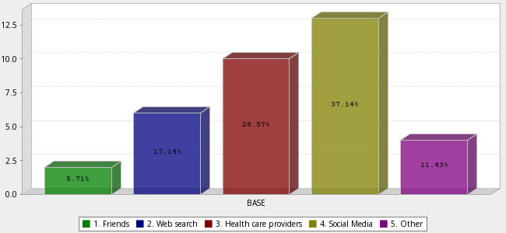
 |  | Answer |  |  |  | Count | Percent
1. |  | Friends |  |  |  | 2 | 5.71%
2. |  | Web search |  |  |  | 6 | 17.14%
3. |  | Health care providers |  |  |  | 10 | 28.57%
4. |  | Social Media |  |  |  | 13 | 37.14%
5. |  | Other |  |  |  | 4 | 11.43%
 |  | Total |  |  |  | 35 | 100%
 | Mean : 3.314 |  | Confidence Interval @ 95% : [2.957 - 3.672] | Standard Deviation : 1.078 | Standard Error : 0.182
Q12. How much do you know about PrEP?

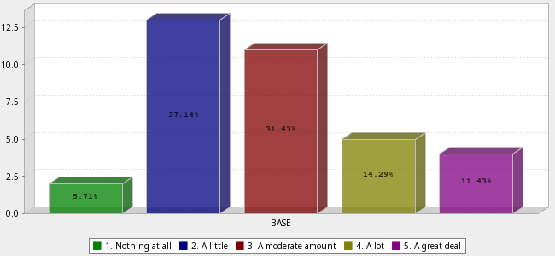
 |  | Answer |  |  |  | Count | Percent
1. |  | Nothing at all |  |  |  | 2 | 5.71%
2. |  | A little |  |  |  | 13 | 37.14%
3. |  | A moderate amount |  |  |  | 11 | 31.43%
4. |  | A lot |  |  |  | 5 | 14.29%
5. |  | A great deal |  |  |  | 4 | 11.43%
 |  | Total |  |  |  | 35 | 100%
 | Mean : 2.886 |  | Confidence Interval @ 95% : [2.520 - 3.252] | Standard Deviation : 1.105 | Standard Error : 0.187
Q13. Let's Learn More!PrEP stands for pre-exposure prophylaxis. It is a prescription medication available as a daily pill or a long-acting injection taken by individuals who are HIV-negative to significantly reduce the risk of contracting the virus. HIV can be contracted through unprotected sexual intercourse and sharing needles.When taken as prescribed, the medication builds up in the bloodstream to block HIV from establishing a permanent infection in the body if an exposure occurs.Was this definition helpful?

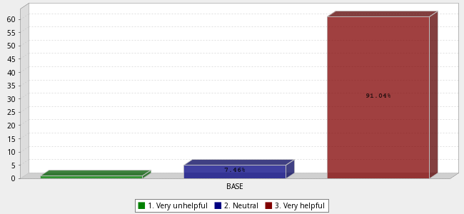
 |  | Answer |  |  |  | Count | Percent
1. |  | Very unhelpful |  |  |  | 1 | 1.49%
2. |  | Neutral |  |  |  | 5 | 7.46%
3. |  | Very helpful |  |  |  | 61 | 91.04%
 |  | Total |  |  |  | 67 | 100%
 | Mean : 2.896 |  | Confidence Interval @ 95% : [2.811 - 2.980] | Standard Deviation : 0.354 | Standard Error : 0.043
Q14. If you were interested in pursuing PrEP counseling and/or treatment, would you consider going to the University Health Center?

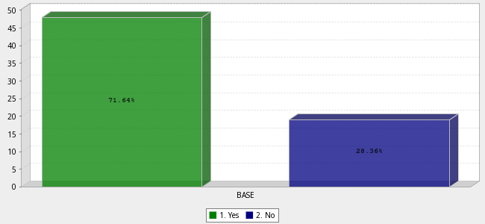
 |  | Answer |  |  |  | Count | Percent
1. |  | Yes |  |  |  | 48 | 71.64%
2. |  | No |  |  |  | 19 | 28.36%
 |  | Total |  |  |  | 67 | 100%
 | Mean : 1.284 |  | Confidence Interval @ 95% : [1.175 - 1.392] | Standard Deviation : 0.454 | Standard Error : 0.055
Q15. If no, why not? (Select all that apply)

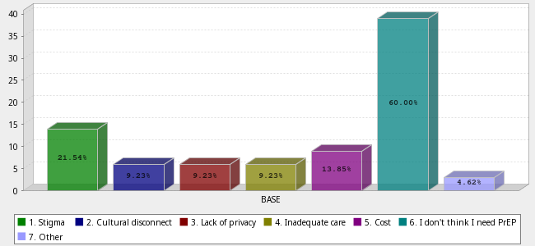
 |  | Answer |  |  |  | Count | Percent
1. |  | Stigma |  |  |  | 14 | 21.54%
2. |  | Cultural disconnect |  |  |  | 6 | 9.23%
3. |  | Lack of privacy |  |  |  | 6 | 9.23%
4. |  | Inadequate care |  |  |  | 6 | 9.23%
5. |  | Cost |  |  |  | 9 | 13.85%
6. |  | I don't think I need PrEP |  |  |  | 39 | 60.00%
7. |  | Other |  |  |  | 3 | 4.62%
 |  | Total |  |  |  | 83 | n = 65.0
 | Mean : 4.434 |  | Confidence Interval @ 95% : [4.001 - 4.867] | Standard Deviation : 2.013 | Standard Error : 0.221
Q16. Would you attend a workshop or seminar on sexual health if offered?

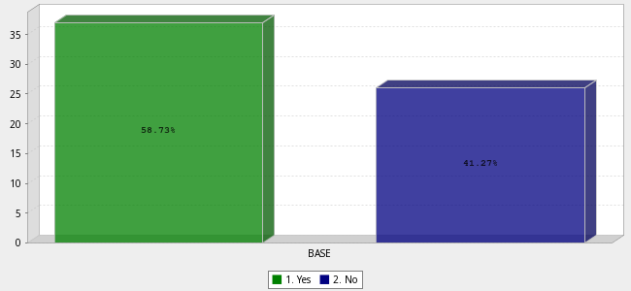
 |  | Answer |  |  |  | Count | Percent
1. |  | Yes |  |  |  | 37 | 58.73%
2. |  | No |  |  |  | 26 | 41.27%
 |  | Total |  |  |  | 63 | 100%
 | Mean : 1.413 |  | Confidence Interval @ 95% : [1.290 - 1.535] | Standard Deviation : 0.496 | Standard Error : 0.063

